**Site-map and Wire-frames**

1. Site-map

1. Wire-frame

Figure1 Home

Figure 2 Brand Recommendation

Figure 3 Brand Story

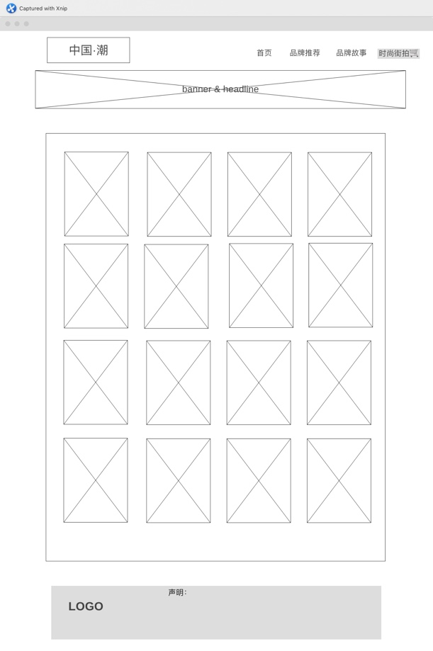

Figure 4 Fashion Shooting

**Usability Test**

After finishing all the wireframes of my website, I invited five of my friends to conduct the usability test. These five friends are passionate about fashion trend and are perfect representations of my target users, which really helped me find issues of website’s usability. Before starting the test, I clarified the purpose of this test and encouraged them to think aloud whenever they were confused or had a better idea, which really helped me have a better understanding of the usability and find issues that I ignored.

There are five main questions I prepared for usability test and their followed actions:

|  |  |  |  |  |  |
| --- | --- | --- | --- | --- | --- |
| Questions | 1 | 2 | 3 | 4 | 5 |
| What do you think this website is about? | e-commerce website | e-commerce website | Chinese fashion brands | Chinese brands become fashionable | Chinese brands become fashionable |
| How do you know which brands are in the website? | Click  “品牌推荐” | Click  “品牌推荐” | Click  “品牌推荐” | Click  “品牌推荐” | Click  “品牌推荐” |
| How do you know the fashion process of a brand? | Click  “品牌故事” | Click  “品牌故事” | Click  “品牌故事” | Click  “品牌故事” | Click  “品牌故事” |
| How do you buy a product? | No idea | 时尚街拍🛒 | 时尚街拍🛒 | 时尚街拍🛒 | 时尚街拍🛒 |
| What confused you during the using journey? | The homepage layout is confused. | The navigation bar is not specific enough. | More fashion news of brands | No obvious problems. | No obvious problems. |

At the beginning of the usability test, I asked my friends if they could tell what the website is about. Two of them thought it was more like an e-commerce website because of homepage’s layout. So, I removed brands’ pictures and moved timeline ahead of the chart to show the developing process of domestic brands in a better way. Besides, one of my friends thought the map’s function is not clear enough. After I told her there would be marks in different colors to show stores in 2009 and 2019, she said it could be crowded, which inspired me to change one map into two maps for comparison. In addition, “潮品牌” used to be in navigation bar, but a subject told me it was too general to know what exactly in this page. So I changed “潮品牌” into “潮牌介绍”, which is more specific.

Most of information was clear to 5 subjects except purchasing function. The first friend browsed the wire-framed for a while without knowing how to buy a product, I realized something vague in navigation. Then I added a shopping cart icon behind “时尚街拍”, so, the rest of four subjects immediately knew they could not only browse fashion shootings but also buy items in this page. In addition, one of subjects wished there could be some latest fashion news related to brands. However, this needs information updating from time to time, due to my limited time, I could not address this need temporarily. By observing behaviors of my friends, I noticed that in “品牌推荐”, they had to scroll through the page to find the brand they were interested in. So, I added a side bar and users can directly reach their interested brand.